As Much As The Water: How Steamboats Shaped Arkansas
Grades 7-12
Social Studies

Length:
One 90 minute block or two 50 minute class periods.

Objectives:
- Students will evaluate the effect of the steamboat on transportation.
- Students will analyze the impact of the steamboat on Arkansas.
- Students will use drawings and photographs of Arkansas steamboats to gain an understanding of their use.
Essential/Compelling Question:
How do technology and innovation impact our lives?
Guiding Questions:
- How did the introduction of the steamboat revolutionize transportation?
- How did the steamboat change the lives of Arkansans?
- How did steamboats bring together the spread out communities that made up Arkansas in the early 1800s?
- How did the steamboat help Arkansas progress to the point of statehood?
- What do the drawings and photographs of the steamboats of Arkansas tell us about their role in our history?
Common Core State Standards:
CCSS.ELA-LITERACY.RH.9-10.1
Cite specific textual evidence to support analysis of primary and secondary sources, attending to such features as the date and origin of the information.
CCSS.ELA-LITERACY.RH.9-10.4
Determine the meaning of words and phrases as they are used in a text, including vocabulary describing political, social, or economic aspects of history/social science.
CCSS.ELA-LITERACY.RH.9-10.10
By the end of grade 10, read and comprehend history/social studies texts in the grades 9-10 text complexity band independently and proficiently.
C3 Frameworks:
D2.His.2.9-12. Analyze change and continuity in historical eras. (GQ 1-4)
D2.His.1.9-12. Evaluate how historical events and developments were shaped by unique circumstances of time and place as well as broader historical contexts. (GQ 1,4)
D2.His.4.9-12. Analyze complex and interacting factors that influenced the perspectives of people during different historical eras. (GQ 2,3)
D2.His.11.9-12. Critique the usefulness of historical sources for a specific historical inquiry based on their maker, date, place of origin, intended audience, and purpose. (GQ 5)
D2.His.14.9-12. Analyze multiple and complex causes and effects of events in the past. (GQ 1-4)
Key Terms:
steamboat, side wheeler, stern wheeler, maritime, technology, innovation
Materials:
Whiteboard or Smartboard, Computer with internet access or Smartboard for videos, “Steamboats in Arkansas” PowerPoint presentation, Attached steamboat photograph and picture analysis worksheet, Encyclopedia of Arkansas entry and worksheet
Opening:
Pose the compelling question: How do technology and innovation impact our lives? On the whiteboard or Smartboard, write down the student responses. Do the responses make one’s life easier? What purpose do they serve? Prompt a discussion of significant technological advances in their lifetimes that ends on the topic of transportation. Then show the following short video that introduces the concept of steamboats and their role in the transportation revolution. https://www.youtube.com/watch?v=PL1fEH49TUE

Activities:
- History of steamboats in Arkansas. Refer back to guiding questions during the presentation. Use the attached PowerPoint presentation to teach students about steamboats and their impact on the people and commerce of Arkansas.
- Picture analysis. Using the provided worksheet, have the students analyze the photograph of the Little Rock Packett Co. steamboat. Any photo analysis worksheet, such as the link provided, can be used to help students understand what is going on in the photograph (http://www.archives.gov/education/lessons/worksheets/photo_analysis_worksheet.pdf). What does this photograph tell us about the role of steamboats in Arkansas in the 1800s and early 1900s? How are the people in the photo taking advantage of this technology?
- Expert content analysis. Print a copy of the following article for each student or put them in groups of 3-4 with a copy of the article. Using the article from the virtual exhibit titled “The Civil War in Arkansas and the Role of Steamboats” (http://ualrexhibits.org/steamboats/virtual-exhibit/the-civil-war-period-and-the-role-of-steamboats/), read the article to the class or ask for volunteers from the groups to read one paragraph each. Then, using the prompts provided at the end of this lesson, use a class discussion forum or individual work to assess the students understanding.
- Expert content analysis. Using the same instructions from activity 3, use the article titled “Steamboats and Riverports: Portal to the World”. http://ualrexhibits.org/steamboats/virtual-exhibit/steamboats-and-riverports-portal-to-the-world/
- Print out or have the students access the Encyclopedia of Arkansas entry on steamboats (http://www.encyclopediaofarkansas.net/encyclopedia/entry-detail.aspx?search=1&entryID=4466). Have the students complete the attached reading guide by answering the questions about the EOA article on steamboats.
Closing:
Refer back to the compelling question and talk about how transportation affects the students lives on a daily basis. How would their lives be different if they weren’t able to move around as they do or if they had to wait longer for consumer goods?
Content Resources:
Encyclopedia of Arkansas entry on steamboats. http://www.encyclopediaofarkansas.net/encyclopedia/entry-detail.aspx?search=1&entryID=4466.
Arkansas: A Narrative History, pp. 159-161.
See the Sultana bibliography on the virtual exhibit page for additional resources on the Sultana disaster. http://ualrexhibits.org/steamboats/virtual-exhibit/archival-resources/

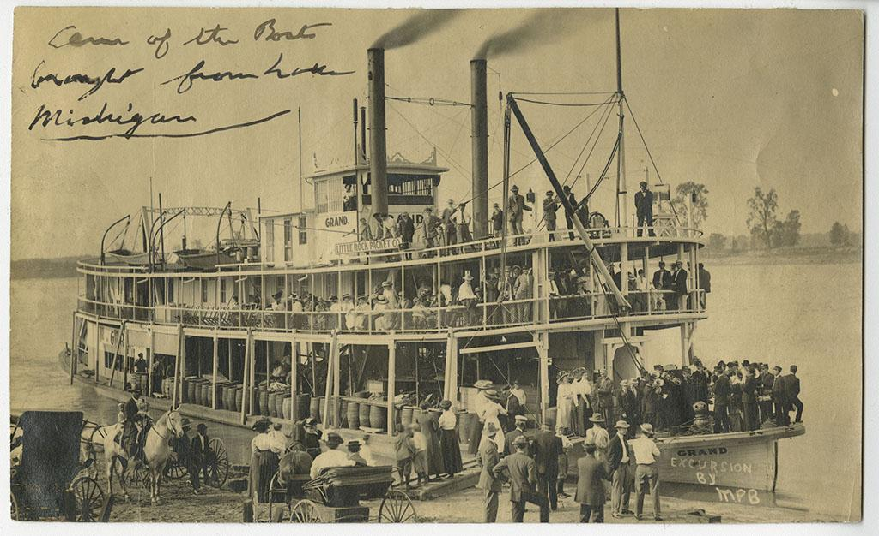
Little Rock Packett Company steamboat, The Grand. Courtesy UALR Center for Arkansas History and Culture.

Name:__________________________ Date:________________________
Steamboats in Arkansas
Used the article from the Encyclopedia of Arkansas about steamboats to answer the following questions.

What did historian Louis Hunter view the steamboat as?

In what year did the Comet reach Arkansas Post?

By 1875, where had steamboats reached in Arkansas?

The form of the steamboat itself came into being in which two decades?

Name the two types of steamboats used in Arkansas.

What was the name of the steamboat that exploded in April 1865 on the Mississippi River?

Steamboats were an integral part of Arkansas transportation from the 1830s to the 1880s until what new mode of travel replaced it?

Steamboats were used in Indian removal. True or False?

What were three things that steamboats transported during the Civil War?

List three ways the steamboat helped revolutionize transportation?

The Civil War in Arkansas and the Role of Steamboats
Dr. Carl H. Moneyhon

- The article states that “Thus, the side that controlled the rivers, had a singular advantage. Unfortunately for Confederate Arkansas, Northern forces early established that advantage.” What aspects of controlling the rivers of Arkansas would have given the Union forces and advantage? What innovations were necessary for Union boats to control the rivers?
- How did the Union gain the advantage on Arkansas rivers? How did the Union control of the rivers aid in their success in capturing Arkansas from the Confederacy?

Steamboats and Riverports: Portal to the World
Dr. Lenore Shoults

- How did steamboats make life easier for all the people of Arkansas, including upper, middle, and lower class citizens as well as the slave population?
- How did life on the steamboats, as well as at the riverports, reflect the culture of the American South in the 1800s?

